Oluyede Eniola
Business Development Manager
Eniola leads our rental operations with a warm, client-focused approach. She connects people with the right properties by marketing available listings, coordinating inspections, and guiding clients through every step of the rental process. Known for her professionalism and attention to detail, she ensures smooth, transparent transactions while building lasting relationships. Eniola is also passionate about growing our client community and expanding the reach of our services.


Boluade Priscilla
Content Creator
Priscilla brings our brand to life through compelling stories and visuals. As our Content Creator, she crafts engaging content that captures our voice, values, and vision. Her passion for storytelling and eye for aesthetics help create messages that truly connect with our audience and showcase what makes our firm unique.

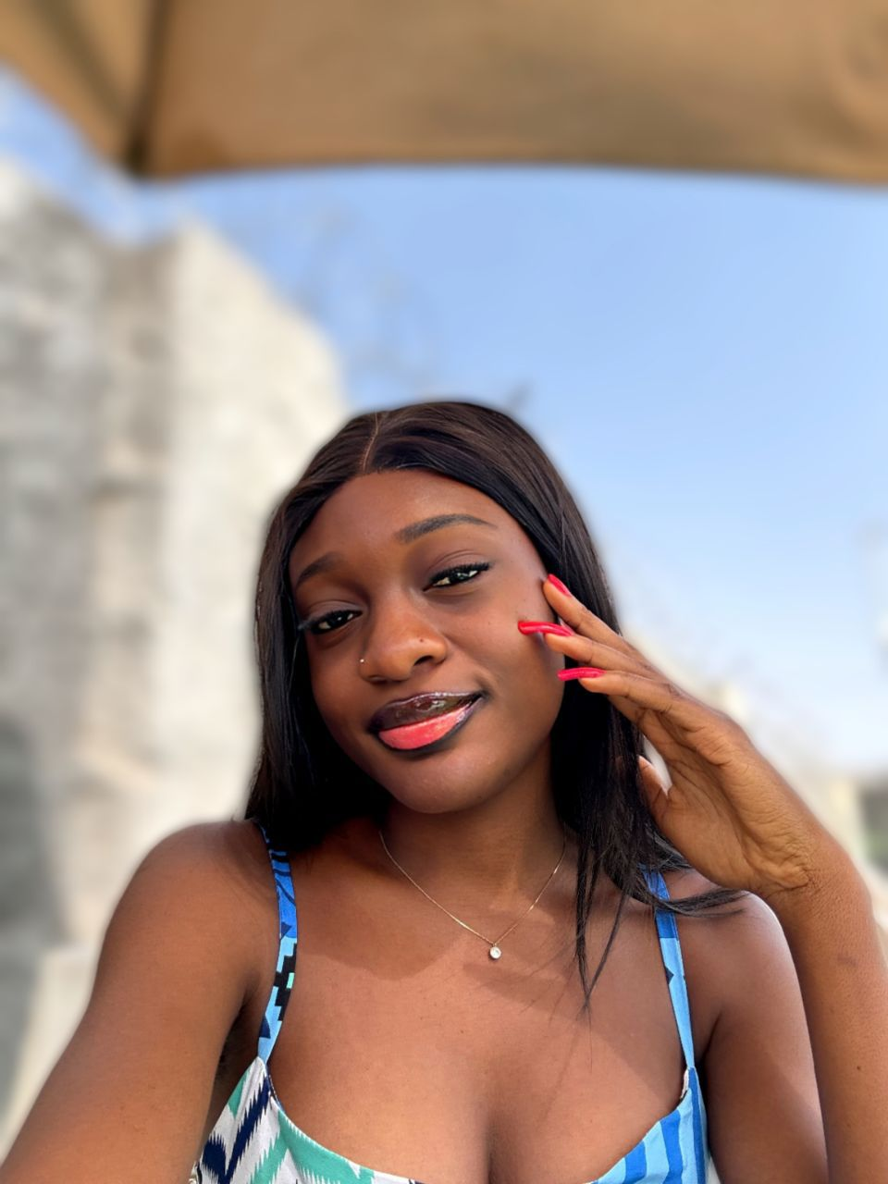

Fatunwase Olalekan
Sales and Marketing Manager
Olalekan leads our sales and marketing efforts with a focus on connection and results. He develops and executes strategies that promote our properties, drive sales, and strengthen our market presence. Known for his leadership and client-first approach, Olalekan manages the sales team and builds lasting relationships that help clients find real value in every transaction.



Michael Oche Ejembi
Social Media Manager
Michael manages our online presence across all social media platforms, ensuring that every post reflects Amon Heights’ brand and values. He shares property listings, updates, and announcements with creativity and precision, keeping our audience informed and engaged. Through his work, Michael helps showcase our properties and connect with clients in meaningful, authentic ways.

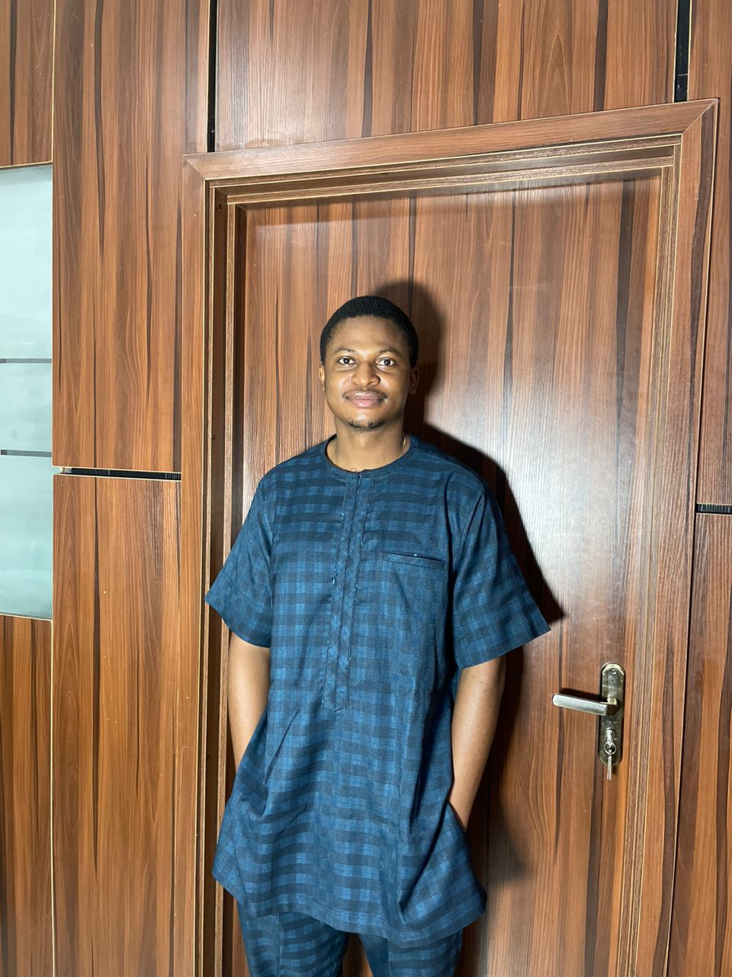

Deborah Ajulo
Sales and Marketing Manager
Deborah leads our real estate sales operations with focus and flair. She drives client acquisition and brand marketing initiatives, ensuring every interaction reflects our commitment to excellence. With a passion for connecting people to the right properties, Deborah plays a key role in growing our client base and strengthening Amon Heights’ market presence.

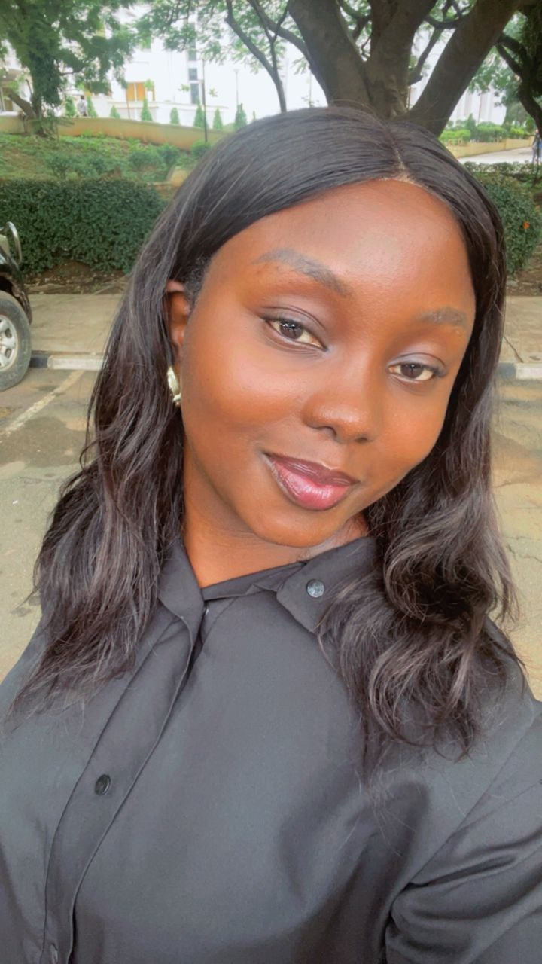

Godwin Progress Chijioke
Social Media Manager & Assistant Business Development Manager
Godwin plays a dual role in supporting both our online presence and business growth. He helps manage our social media platforms, promotes property listings, and engages with clients to ensure every interaction is smooth and professional. In his business development role, he assists in marketing properties and coordinating rental transactions, helping clients enjoy a seamless experience from inquiry to move-in.



Suzan Animashaun
Content Creator
Suzan brings creativity and flair to Amon Heights’ digital presence. She manages our TikTok page—creating and editing videos, following trends, and keeping our audience engaged. With her passion for storytelling and visual appeal, Suzan ensures our content stays fresh, entertaining, and always on-brand.

